**DAILY ONLINE ACTIVITIES SUMMARY**

|  |  |  |  |  |  |  |  |
| --- | --- | --- | --- | --- | --- | --- | --- |
| **Date:** | **19May 2020** | | | | **Name:** | **KHATHEEJA SAFREENA** | |
| **Sem & Sec** | **4th sem A** | | | | **USN:** | **4AL18CS037** | |
| **Online Test Summary** | | | | | | | |
| **Subject** | | **DDA** | | | | | |
| **Max. Marks** | | **30** | | **Score** | | **12** | |
| **Certification Course Summary** | | | | | | | |
| **Course** | **Workshop on Python for Beginners.** | | | | | | |
| **Certificate Provider** | | | **Brainovision.** | **Duration** | | | **1.5hrs** |
| **Coding Challenges** | | | | | | | |
| **Problem Statement:I solved 2 problem statement** | | | | | | | |
| **Status: executed** | | | | | | | |
| **Uploaded the report in Github** | | | | **Yes** | | | |
| **If yes Repository name** | | | | **[http://http://shafreenasharief / lockdown-coding](http://http://shafreenasharief / lockdown-coding" \o "http://http://shafreenasharief / lockdown-coding)** | | | |
| **Uploaded the report in slack** | | | | **Yes** | | | |

Online Test Details: (Attach the snapshot and briefly write the report for the same)

Certification Course Details: (Attach the snapshot and briefly write the report for the same)

Coding Challenges Details: (Attach the snapshot and briefly write the report for the same)

Online Test Details:

Today DDA test was conducted of the first module .Total marks for the test was 30.

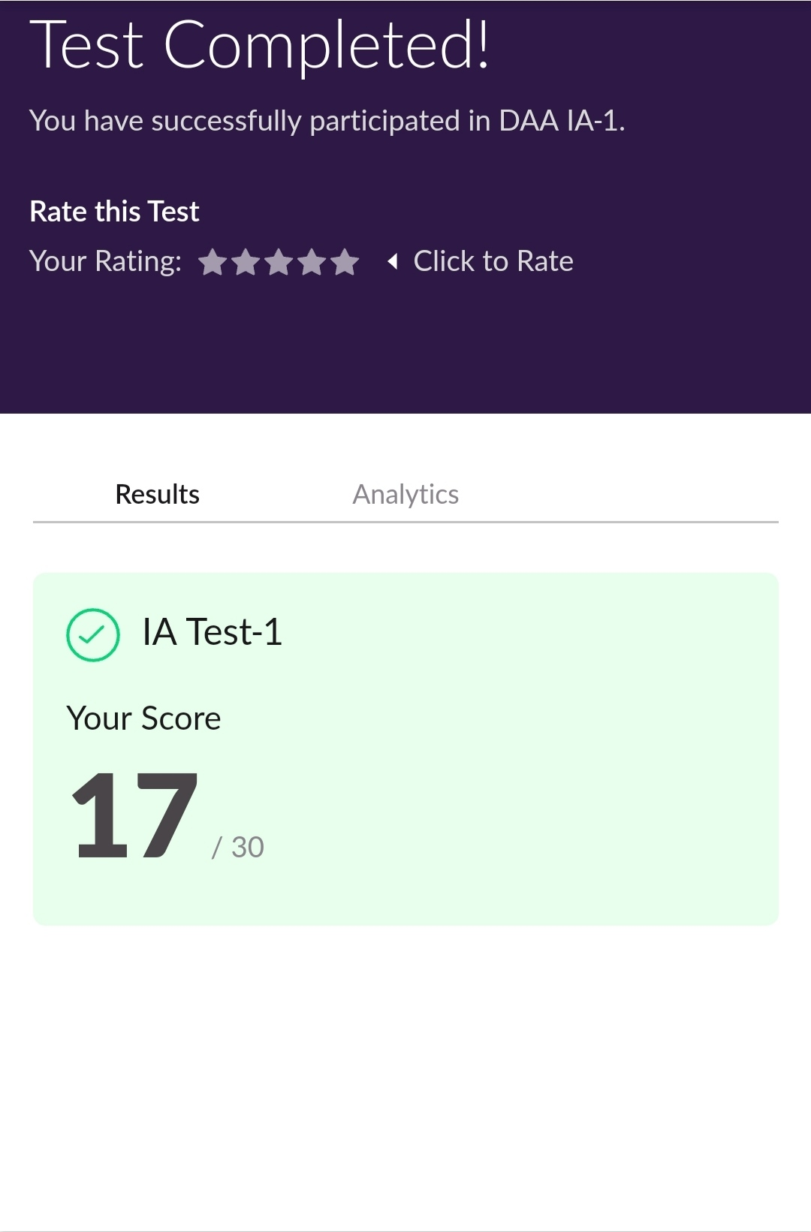

**Certification Course Details:**

* I Attended a "WORKSHOP ON PHYTON" of BRAINOVISION . I was able to complete 1.5 HR of live sessions activities and complete the questions which were asked.

**The concepts covered in Workshop 0n Python for Beginners are:**

* Python Programming.
* Intro to Python.
* Variables & types.
* Numbers &Maths.
* Input from users.
* Passing Arguments.
* Indentation & block of codes.

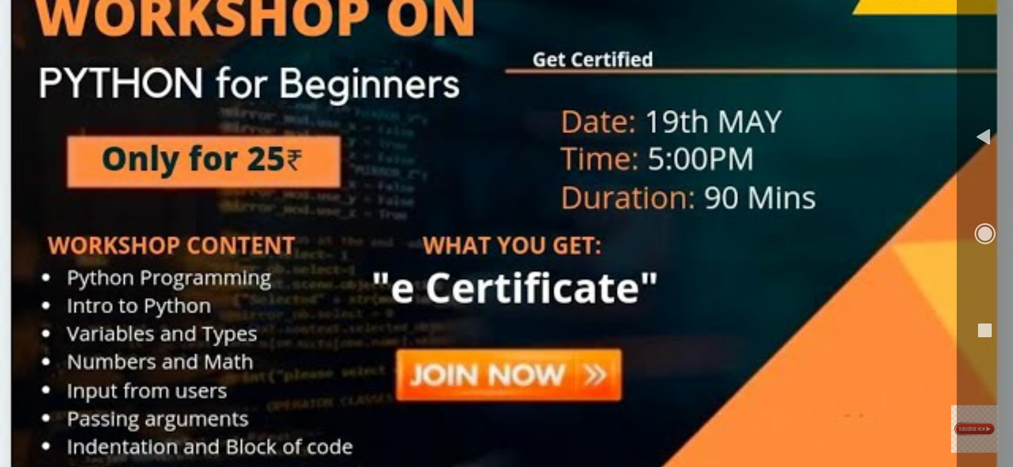

* **Coding Challenges Details:**

1.A user will input two strings, and we find if one of the strings is a sub sequence of the other. Program prints “yes” if either the first string is a sub sequence of the second string or the second string is a sub sequence of the first string. Assume that, the length of the first string is smaller than or equal to the length of the second string.

2.Write a C program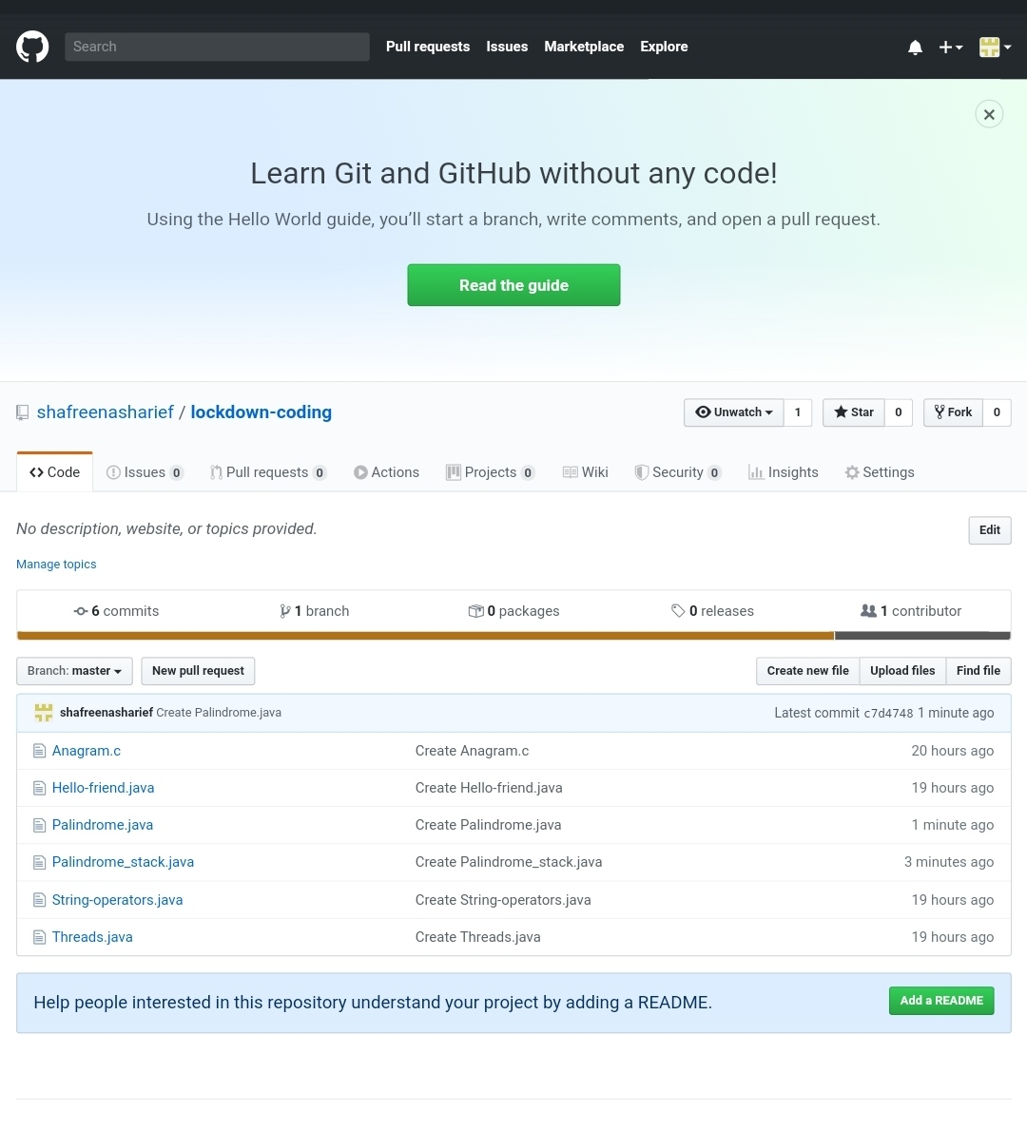 to check whether the two strings are Anagram or no.